**1) STATE DIAGRAM PASSPORT AUTOMATION SYSTEM**

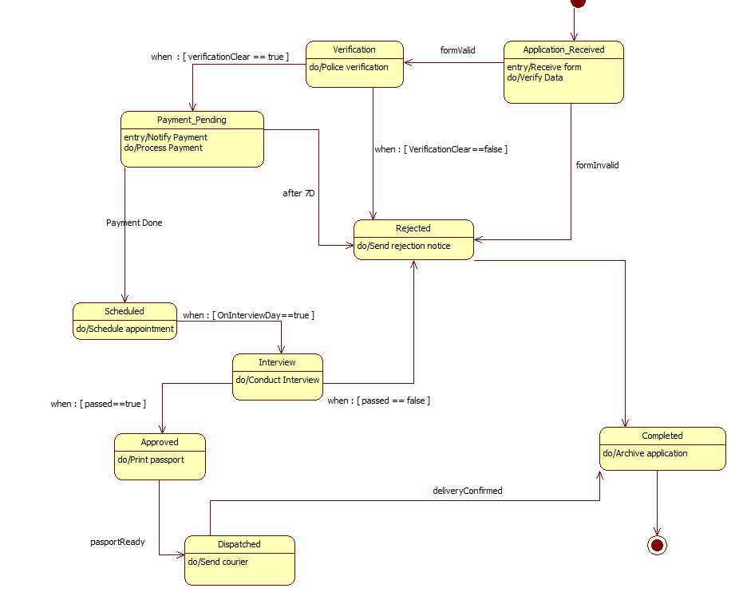

**2) STATE DIAGRAM STOCK MAINTAINANCE SYSTEM**

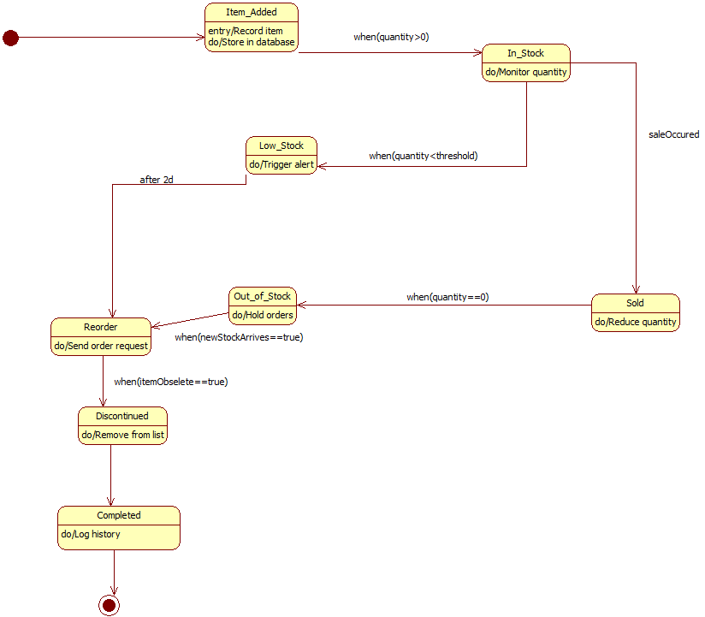

**3) STATE DIAGRAM CREDIT CARD PROCESSING SYSTEM**

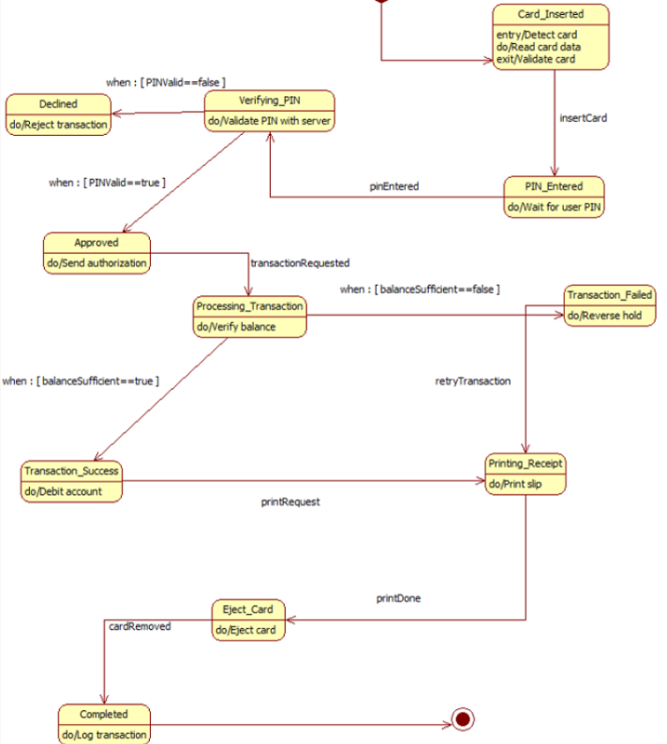

**4) STATE MODEL LIBRARY MANAGEMENT SYSTEM**

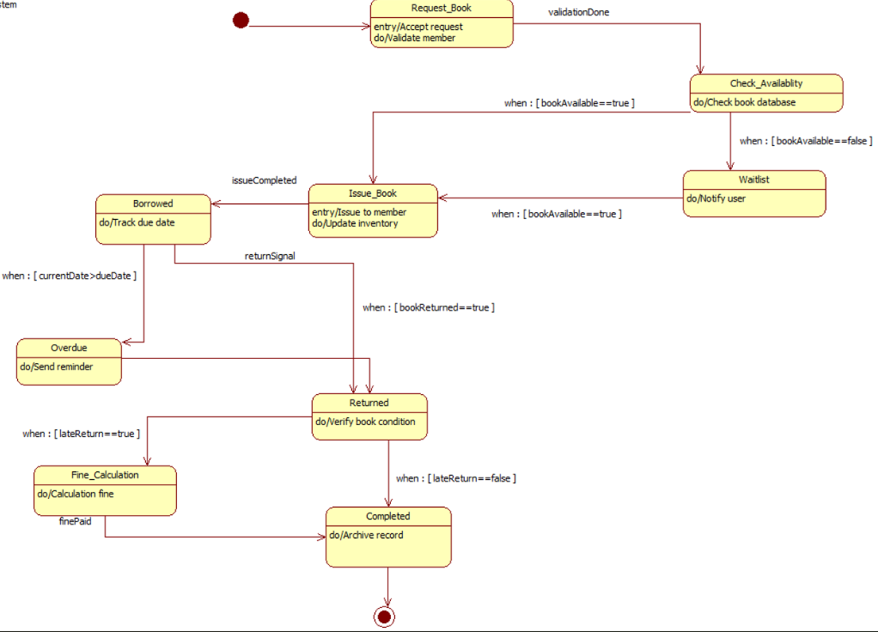

**5) STATE DIAGRAM HOTEL MANAGEMENT SYSTEM**

